INTERNSHIP CERTIFICATES

~ARYA A

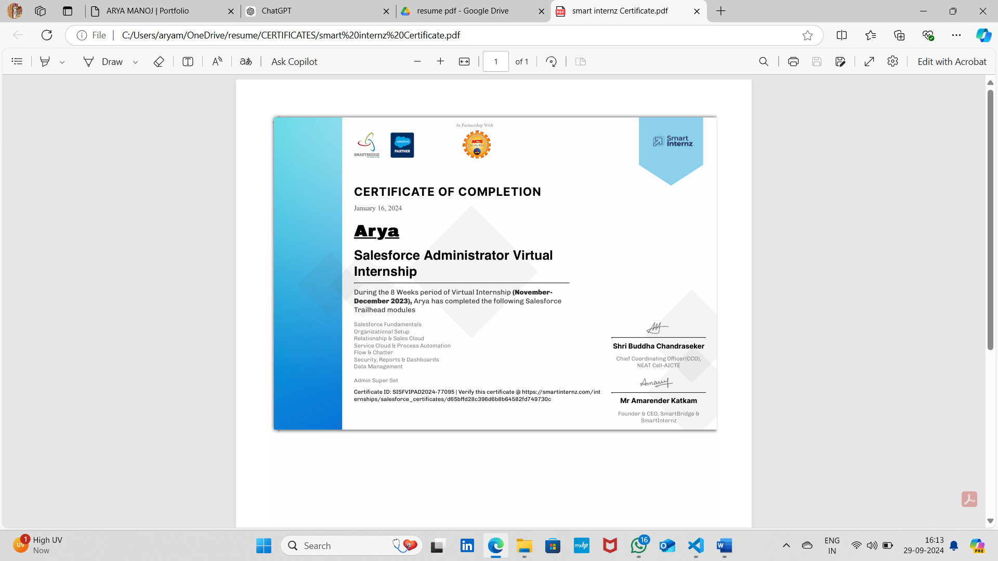

SALESFORCE ADMINISTRATOR INTERN ,AT SMART INTERNZ HYDERABAD(ONLINE MODE)
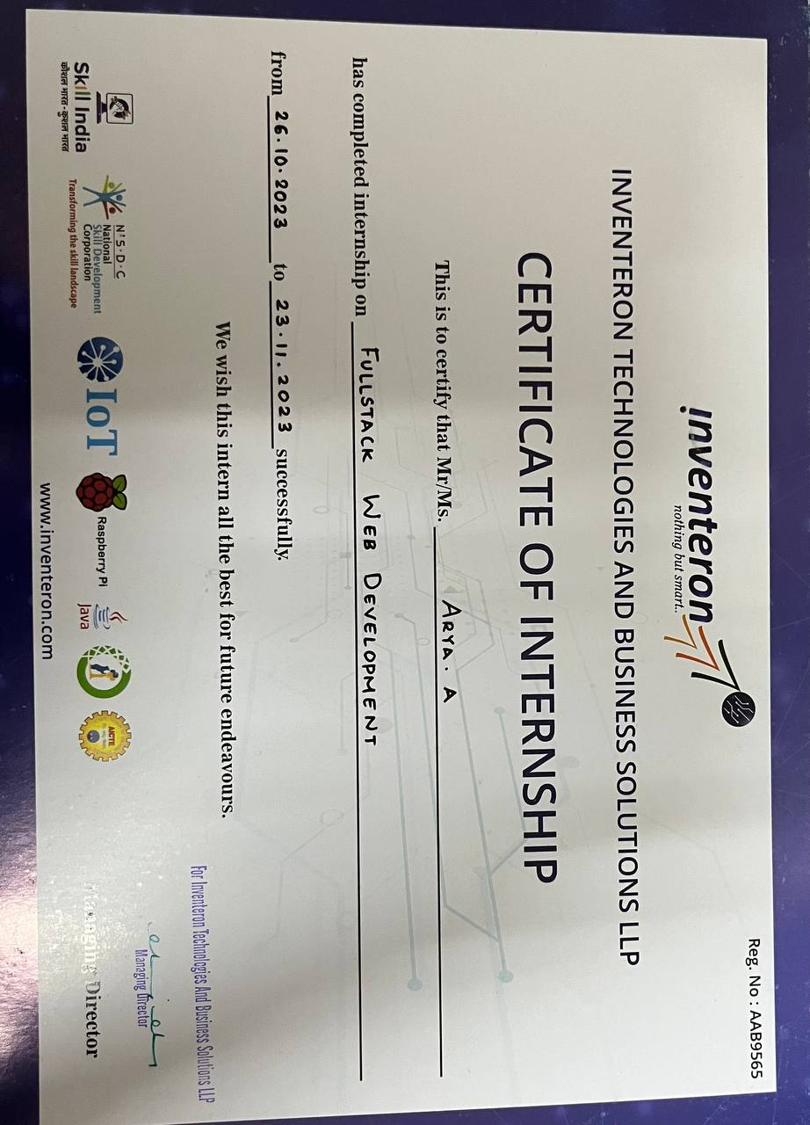 FULL-STACK DEVELOPMENT INTERN AT INVENTERON TECHNOLOGIESBENGALURU, (ONLINE)

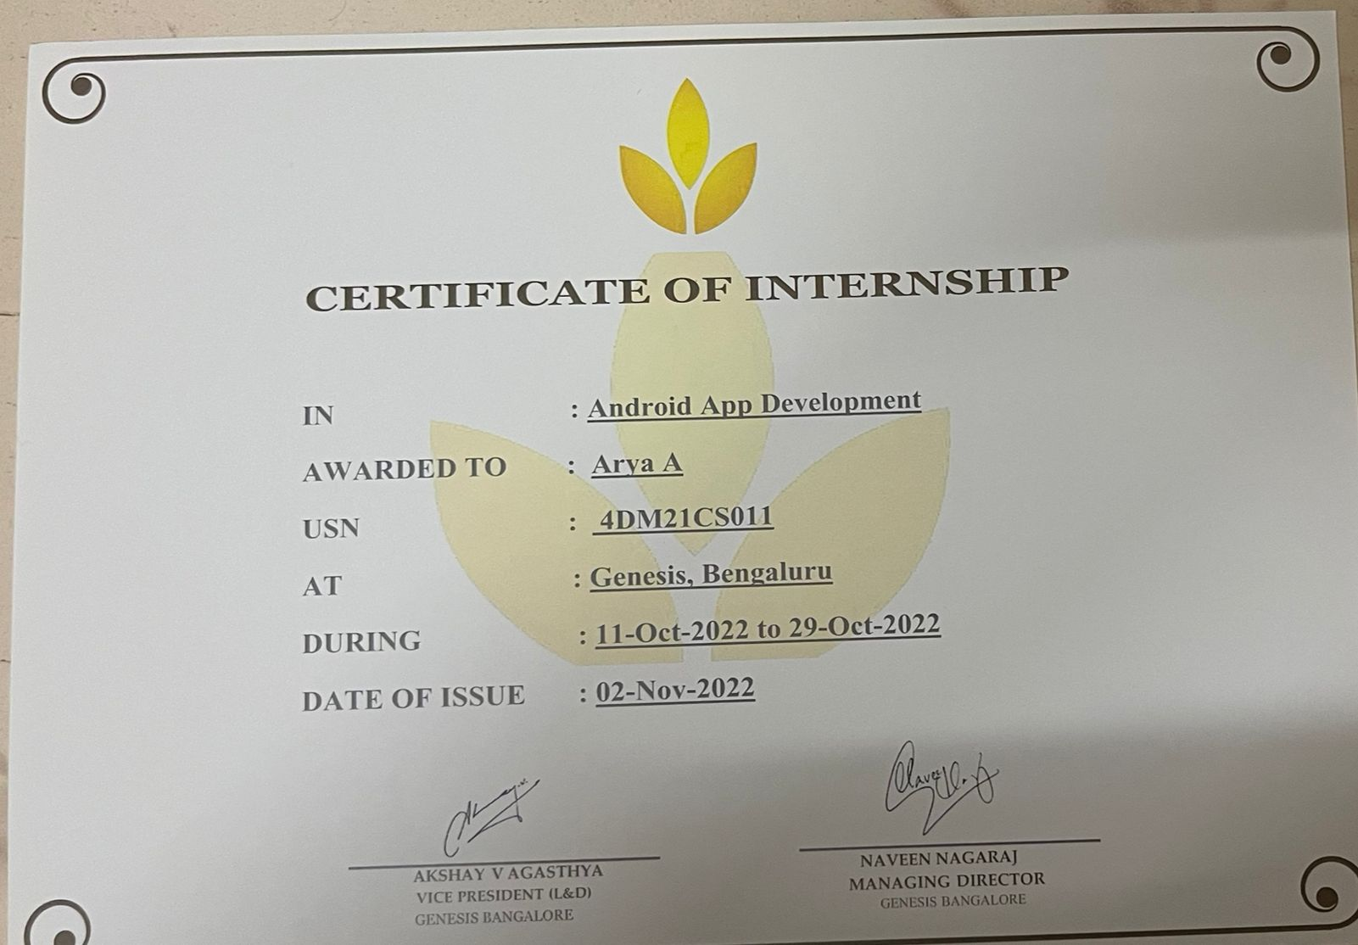

ANDROID APP DEVELOPMENT INTERN AT GENESIS TRAINING MANGALURU, (ONLINE)

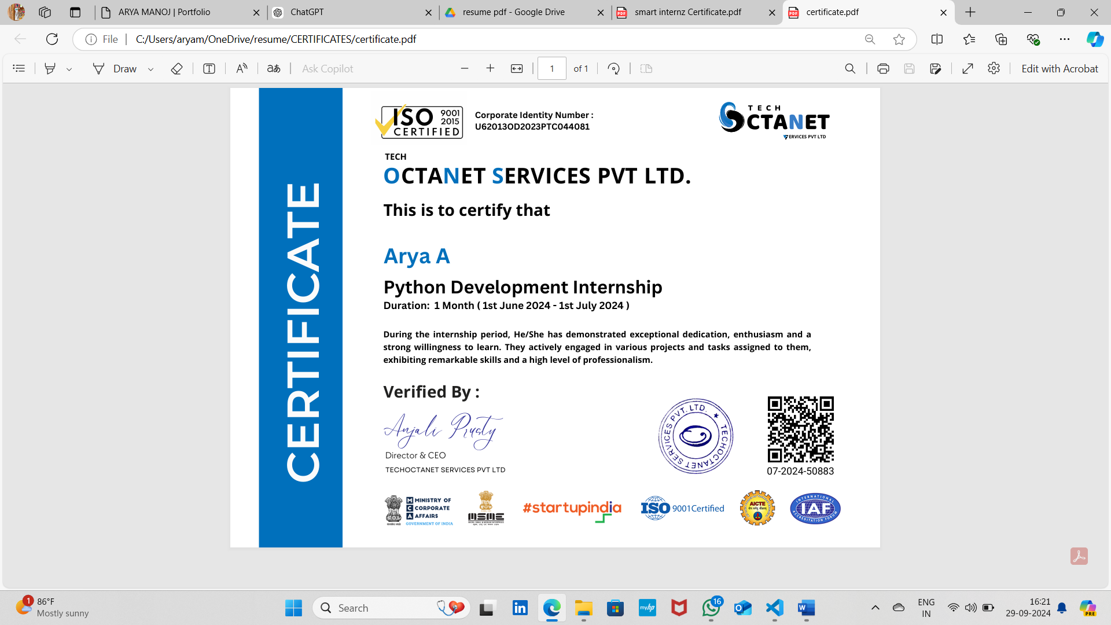

PYTHON DEVELOPER INTERN AT TECHOCTANET PVT LTD ,BENGALURU(OFFLINE)

